Best Java Full Stack Training Institute in Chennai

Java Full Stack Training in Chennai at Htop Solutions offers Java Full Stack Course in Chennai. This course provides you with a detailed outline and integrated learning opportunity that will prepare you for a job as a full stack developer once you have completed the program's requirements. Enrol for a free demo and know more about Java Full Stack Training course in Chennai.

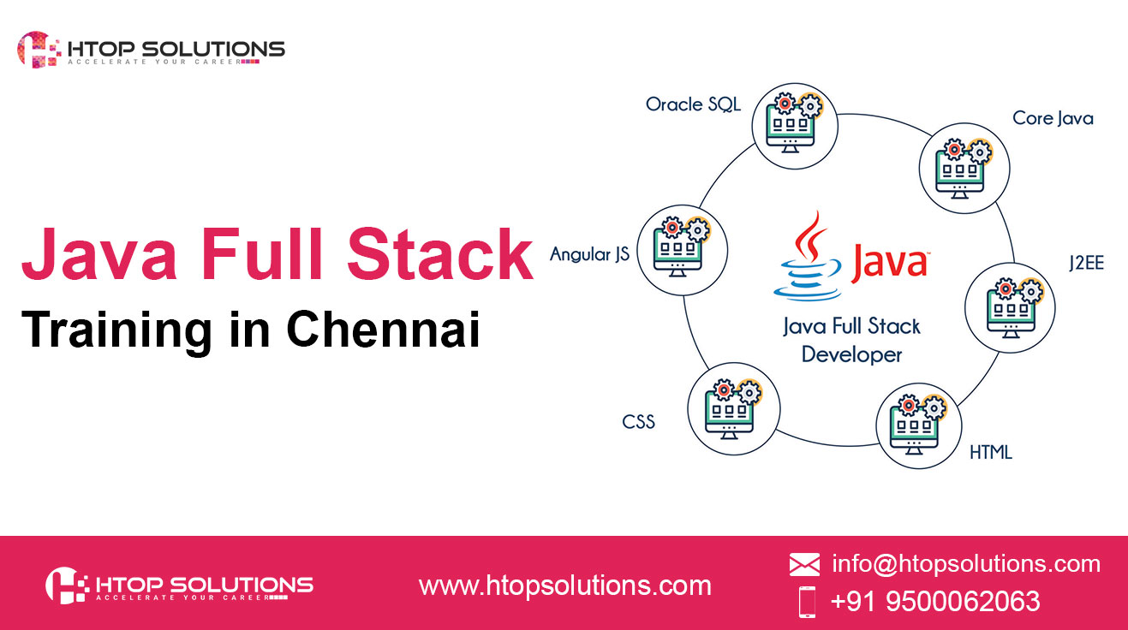

About Our Java Full Stack Trainers

• Streamlining terminology and concepts of the full stack will be assisted trainers
• If you use the whole stack qualifications, that would be helpful
• We have teachers with more than 10 years of development expertise
• Coaches may provide expert advice on ideas, fundamentals and networks for software development
• A typical IT interview CV may be prepared by our professional trainer
• Specialists in companies should provide actual lessons
• Trainers may support candidates in real time in performing activities and services
• They are skilled and expert instructors to assist you understand the advantages and advantages of full java.
Learn Java fullstack training in Chennai from Htop Solutions. Call us at, 8489907812 or Mail info@htopsolutions.com For more details, https://www.htopsolutions.com/

