puravive
weight management support
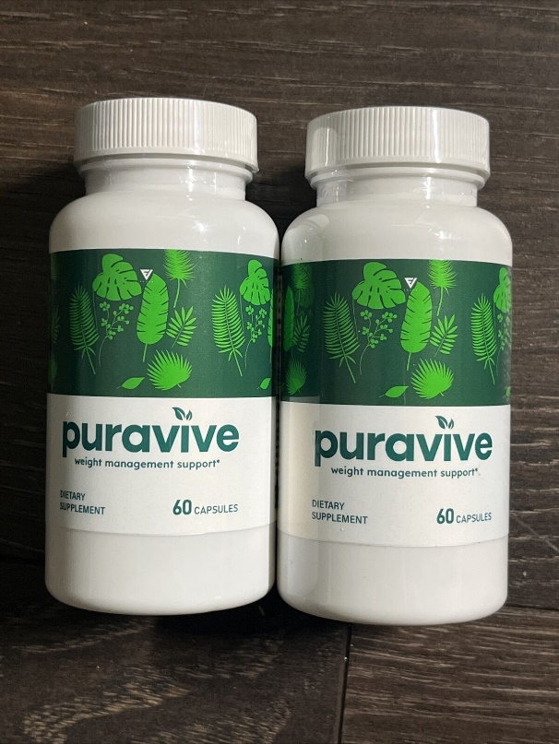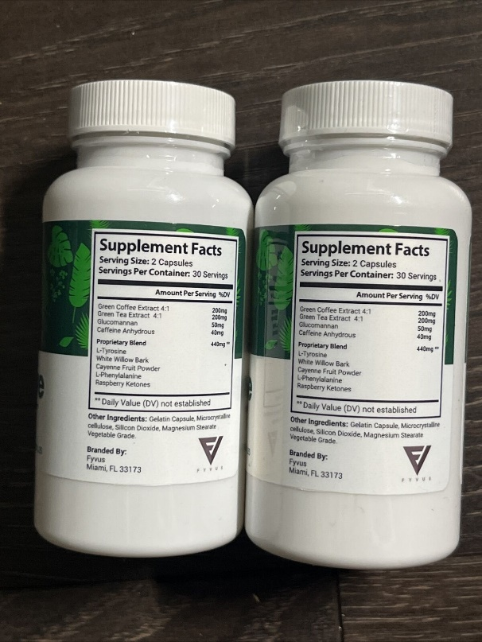
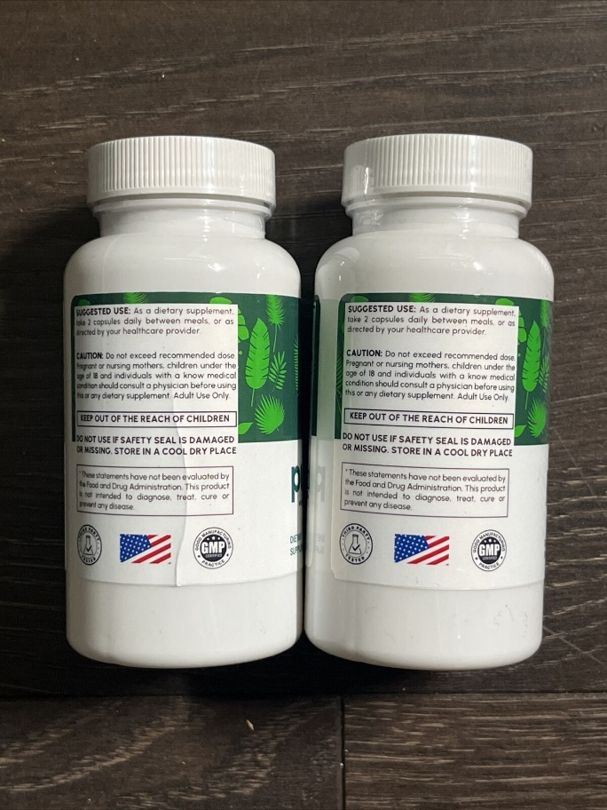

What is Puravive?
Puravive – the new star in the weight loss sky? Obesity is a growing health concern. As the prevalence of obesity increases, so does the focus on weight loss methods, including diets, exercise programmes and supplements. However, this growing demand has fuelled a problematic element: the emergence of dubious, ineffective products.
In this turbulent landscape of weight loss strategies, a new entrant, Pura Vive, has recently begun to make an impact. Departing from conventional weight loss narratives, it has introduced an innovative strategy that focuses on increasing the body’s brown fat – a novel approach in this context.
But for those new to the concept, questions remain: What exactly is brown fat? How does it fit into the wider context of weight management? And is it really possible for a supplement to boost its production and functionality? The most important questions about Puravive are answered below.
Puravive stands out in the crowded weight loss market with its unique, natural formula designed to target stubborn fat and convert it into energy, promoting both weight loss and vitality. Its combination of premium natural ingredients, carefully selected for their specific properties, makes it a safe and effective choice for weight management.
Suitable for a wide audience and easily accessible over the counter, Pura Vive’s approach is based on ground-breaking research. This research identified a lack of brown adipose tissue (BAT) as a key factor in weight gain. By targeting this BAT deficiency, Puravive offers a novel and scientifically-backed solution for effective weight management.

What is Backing Puravive?
White Korean Ginseng: In ancient herbal traditions, White Korean Ginseng shines as a valuable find. Beyond being an herb, it acts as a natural adaptogen, renowned for boosting physical performance significantly. When you experience revitalization, not only does your daily output increase, but you’re also inclined to engage in more physical activities, leading to an uptick in calorie expenditure fueled by enhanced endurance and vitality.
Luteolin: In the realm of natural compounds, there is an abundance of flavonoids, yet Luteolin occupies a unique position. Besides its powerful antioxidant abilities, it acts as a potent combatant against inflammation, particularly the type associated with obesity. By tempering inflammation, it paves the way for effective blood sugar regulation and increased insulin sensitivity, fundamental aspects of effective weight control.
Amur Cork Bark: Embedded within the core of the Amur Cork Bark are elements that support weight loss from various perspectives. Whether it involves reducing inflammation, optimizing metabolic processes, or maintaining stable blood sugar levels, this component serves as a multi-faceted tool in the battle for weight management. Additionally, with better-balanced blood sugar, those persistent cravings can be subdued.
Propolis: In the intricate web of the natural world, bees establish their presence through the creation of Propolis. This resinous marvel has the potential to regulate our gut health, reduce inflammation, and enhance digestion. In the battle against weight management, it’s not solely about the intake and expenditure of calories, but also about the efficiency of our internal ecosystem. According to research, Propolis could be a crucial ally in maintaining this internal equilibrium.

Product details:
Support healthy weight loss
Supports fat burning
More energy
Price: $59.00
Rating ⭐⭐⭐⭐⭐

How It work PuraVive?
PuraVive works on a splendid and complicated utilitarian system, which separates it as a viable weight reduction supplement. Understanding how it functions is vital to see the value in its part in assisting people with shedding undesirable pounds and accomplish their weight reduction objectives.
One of the vital instruments by which PuraVive advances weight reduction is through its capacity to invigorate digestion. Digestion alludes to the amount of all synthetic responses that happen in the body to support life and energy creation. PuraVive contains fixings that explicitly target metabolic cycles, expanding the body's energy consumption and advancing calorie consume.
By improving digestion, PuraVive Expert really changes the body toward a higher gear, prompting expanded calorie consume in any event, when very still. This implies that people can consume more calories over the course of the day, supporting the breakdown of fat stores and adding to weight reduction.
As well as helping digestion, PuraVive contains fixings that go about as craving suppressants. These mixtures assist people with controlling their food desires and decrease their general calorie admission. By checking the longing to gorge or enjoy unfortunate bites, PuraVive backings people in taking on a controlled and adjusted diet, critical for effective weight reduction. It is critical to take note of that PuraVive practical instrument is far reaching and complex. Its fixings work as one to address various parts of weight reduction, focusing on metabolic rate, craving control, fat breakdown, and energy levels. This all encompassing methodology guarantees that people have the instruments they need to defeat the difficulties related with weight collection.

The Science Behind Puravive
The key to Puravive's effectiveness lies in its ability to boost the body's brown adipose tissue levels. Brown fat, unlike white fat, has the unique ability to burn calories and convert them into energy. However, factors such as aging and an unhealthy lifestyle can lead to a decrease in brown fat levels, making weight loss more challenging. Puravive's carefully curated blend of natural ingredients, including luteolin, kudzu, holy basil, white Korean ginseng, amur cork bark, propolis, quercetin, and oleuropein, works synergistically to revive brown fat and promote weight loss naturally.
The Benefits of Puravive
Puravive offers a range of benefits that extend beyond weight management. Here are some of the key advantages of incorporating Puravive into your daily routine:
Promotes Healthy Weight Loss: By increasing brown adipose tissue levels, Puravive helps the body burn calories more efficiently, resulting in sustainable weight loss.
Boosts Metabolic Processes: The natural ingredients in Puravive support a healthy metabolism, aiding in the breakdown of fats and promoting efficient energy utilization.
Reduces Inflammation in the Body: Puravive's antioxidant-rich composition helps combat inflammation, which is often associated with obesity and other health issues.
Enhances Energy Levels: By converting stored fat into energy, Puravive provides a natural energy boost, allowing individuals to feel more active and alert throughout the day.
Strengthens Immune Cells: Certain ingredients in Puravive, such as white Korean ginseng and propolis, have immune-boosting properties, supporting overall well-being.
Contributes to Overall Health: Puravive's holistic approach to weight management ensures that the body receives essential nutrients, promoting the optimal functioning of various organs and systems.
Dosage- 1 Capsule Per Day

Pros
Manufactured Using Pure Natural Ingredients
Does Not Contain Any Chemicals Or GMOs
Manufactured In FDA-Approved And GMP-Certified Facilities
Offered At An Affordable Cost With Added Discounts
100% Money-Back Guarantee For 180 Days
Only Available For Purchase On The Official Website

Cons
Results Can Vary From Person To Person
Stocks Can End Fast
Side Effect- No Side Effects Have Been Reported
Price- $59 For One Bottle
Availability- Only On The Puravive Official Website
Ingredients Used To Formulate Puravive Weight Loss Supplement
Puravive ingredients have a track record of serving humans to overcome numerous health odds and have been clinically proven. In this section, we will have them listed so that you understand their benefits. Please carefully read the content provided below for a clear understanding of its merits.
Luteolin:
Luteolin helps to restore brown adipose tissue, reduces stress, and offers better brain functions. It promotes eye health and improves the cognitive functions of the body. Luteolin also has antioxidants that inhibit the influx of free radicals and lower inflammation.
Kudzu:
Kudzu is an organic compound that helps to lower stress and offers protection to the cardiovascular system. It helps optimize brain function and improve neurological function. Kudzu also regulates blood sugar levels and offers better immunity.
Holy Basil:
Holy basil is a natural immunity booster and helps to reduce stress and anxiety. It supports optimal blood pressure and offers relief from kidney stones. Holy basil also has anticancer properties, which deter various types of cancer.
White Korean Ginseng:
White Korean ginseng benefits health in many ways, such as reducing inflammation, boosting brain functions, and fighting fatigue. White Korean ginseng helps to balance lipid levels and offers better endurance to the body. White Korean ginseng also strengthens memory and offers better mental acuity.
Amur Cork Bark:
Amur cork bark offers better liver health and supports healthy digestion. It helps reduce blood pressure and offers immunity to body cells. Amur cork bark also improves neurological functions and strengthens the nervous system.
Propolis:
Propolis has significant skincare benefits and speeds up wound healing. It also helps reduce inflammation and offers oral hygiene. Propolis also positively impacts brain functions and improves the cognitive functions of the body.
Quercetin:
Quercetin offers anticancer properties and protection against heart diseases. It can aid in the treatment of certain allergies and has been found to boost brain functions. Quercetin also helps to regulate blood sugar levels and offers better immunity.
Oleuropein:
Oleuropein is rich in antioxidants and lowers instances of inflammation in the body. It is mainly used to treat blood pressure and offer optimal cardiovascular benefits. Oleuropein also helps to improve metabolism and supports healthy digestion.

The effectiveness of Puravive diet pills
The company that created Puravive diet pills is confident that this product will bring extraordinary results. This is the chief reason; it allows every person to enjoy a money-back assurance if he does not become content with the product. If you feel that Puravive isn’t bringing any positive alterations to your weight or giving rise to adverse side effects, you can contact the customer care team to share your concerns. However, it would help if you were mindful of sharing your name, order date, and order number.
This piece of information will help you find your entry in the records of the company. After you complete this information, you can send back your bought bottles and successfully get a refund. However, this amount only includes the delivery charge if you have paid it. Within 180 days, you will get your refund. Customers find this time to be sufficient to attempt this formula as well as notice the effects. However, if the company receives a refund request after this period, it will discard your request without letting you know. A person becomes qualified for a refund only when he orders using the product’s official website.
The unique features of Puravive weight-shedding supplement
People rely on the Puravive weight-shedding supplement as it has many exceptional features. Hence, it gets nothing but optimistic reviews online. Some top features of Puravive are:

Puravive prevents stimulants
Most weight-shedding supplements depend on stimulants to provide a person’s body with some extra benefits like cognitive abilities and enhancing brain power. Though it seems excellent in the short term, when people take it for a longer duration, it affects their health. Due to this reason, the creators who created the Puravive supplement didn’t use these stimulants. This supplement is famous for hindering the utilization of these kinds of stimulants, which is why it has managed to get lots of optimistic Puravive reviews from customers who do not bother about becoming addicted to it.

Every person can enjoy Puravive health benefits.
Numerous reviews of Puravive prove that people get an extra reason to invest in this supplement. Every weight loss pill of Puravive has been formed in an FDA-sanctioned facility. According to the authorities, due to this reason, this weight loss-endorsing supplement is considered to be one of the most benign supplements present on the market.

Created from only 100 percent natural components
Every natural ingredient in the capsules of Puravive is filled with many exotic nutrients, as its base formula has been created from tropical islands. Due to the utilization of 100 percent natural and plant-based ingredients, Puravive can become a comparatively safer choice for people who want to diminish fat cells. The notable thing about this product is it is devoid of hazardous additives.

Get known to the creators of Puravive.
The makers of Puravive should be given the credit for creating this supplement that has got lots of positive reviews. Some medical experts who have years of experience in the sphere of burning fat cells and weight loss made it. They researched for a long time and came forward with a formula that can assist people in lessening their appetite besides improving their general health. Puravive lessens a user’s waist circumference as it lessens the levels of white fat in his body.
The makers of Puravive intend to assist ordinary people in enjoying an escalated metabolism, burning calories, and endorsing brown adipose tissue levels in their bodies without burning their pockets to buy this product.

Puravive Weight Loss Reviews: Puravive Reviews Complaints
If we check the Puravive review online, this supplement has a high customer base. The reason behind this hype is nothing but its effectiveness on the users. From the first impression, this supplement seems to be legit.
The manufacturer has provided the details of the supplement on the fact label. If you are interested to know more about the supplement, read this review till the end.
This Puravive review aims to deal with every aspect of the supplement, such as its ingredient list, health benefits, working mechanism, pricing, availability, side effects, and more.
You will get a clear understanding of the supplement after going through each section of this review. So, let’s jump into the review without any ado.

What is Brown Adipose Tissue (BAT)?
Brown adipose tissue, also known as brown fat, is a type of fat that can generate heat and burn calories. It gets its brown color from the high number of mitochondria it contains.
Mitochondria are the “engines” inside cells that convert nutrients into energy. BAT is packed with mitochondria, which gives it a dense, brown appearance.
Unlike white fat that stores calories, BAT is active fat that burns calories to produce heat. This process is called thermogenesis. When BAT is activated, it ramps up calorie and fat burning. Even small amounts of BAT can burn a significant amount of energy.
Research shows lean people tend to have more brown fat than overweight or obese individuals. Boosting low levels of BAT could potentially help increase calorie expenditure and promote weight loss.
That’s why brown fat is an area of interest in treating obesity. Some strategies like cold exposure or certain foods/supplements may help turn white fat “beige” and take on characteristics of calorie-burning brown fat.
While more human research is needed, targeting BAT provides a promising new approach to obesity treatment and weight management. Puravive natural ingredient formula claims to naturally increase BAT levels without cold exposure, but the evidence is still preliminary.

Why Puravive Formula Outplays Other Supplements
Puravive’s effectiveness is not just a marketing claim, and all the Puravive reviews from customers back this statement. It has demonstrated its superiority over other dietary supplements in terms of supporting weight loss:
FDA-Approved Laboratories: Puravive is manufactured in FDA-approved laboratories, ensuring the highest standards of safety and quality in its production process. This level of oversight distinguishes it from many other supplements that lack such rigorous regulation.
GRAS-Certified Components: Puravive uses components to support successful weight loss objectives that are Generally Recognized as Safe (GRAS) by the FDA, underlining its commitment to safety and efficacy.
Advanced Smart Technology: The production of Puravive relies on cutting-edge smart technology to maintain the purity and potency of its ingredients. This technological edge ensures that the supplement consistently delivers on its promises.
Free from Gluten and Banned Substances: Puravive is not just a product to help you lose weight, it’s also a product for better health. It’s free from gluten and other banned substances, making it suitable for a wide range of dietary preferences and restrictions.
No Side Effects: Many weight loss supplements come with a laundry list of potential side effects, including jitteriness, nausea, and sleep disturbances. Puravive, on the other hand, has been designed to be gentle on the body and does not cause any of these unwanted side effects.
Clinical Trials: The ingredients in Puravive have undergone rigorous clinical trials to establish their safety and effectiveness in terms of supporting one’s healthy weight loss journey. This commitment to scientific scrutiny sets it apart from supplements that lack such evidence.
Puravive has thus established itself as a clear leader in the weight loss supplement market by combining the power of natural ingredients, a commitment to safety and quality, and a dedication to scientific validation.
In summary, Puravive represents a natural, safe, and scientifically validated approach to excess weight reduction. Its ingredients are chosen for their specific roles in promoting healthy weight management, and its production adheres to the highest quality standards. This supplement is a game-changer in the world of dietary supplements, and its numerous success stories and scientific backing attest to its effectiveness and safety. It’s a powerful tool for those seeking to achieve their weight loss goals while prioritizing their overall health and well-being.

Production Standards:
Puravive is produced in an FDA-approved facility following GMP guidelines
It is free from synthetic materials, GMOs, and harmful preservatives
The weight loss supplement contains only clinically proven natural ingredients
It is free from adverse effects and can be taken without a prescription
Refund/Return Policy: Iron-clad 180-day money-back guarantee
Delivery Time:
USA: 5-7 working days
Other Locations: 7-15 working days
Customer service:
1-800-390-6035
Contact@Puravive.com
Pricing: You can buy one bottle of Puravive for as low as $39 (Official Website)

Puravive Reviews – Are Customers Satisfied With Results?
Navigating through the myriad of Puravive reviews, a clear pattern of contentment emerges. The product boasts an enviable collection of five-star ratings, signaling its efficacy and users’ trust. Within these Puravive reviews, users frequently express their elation over visible results, whether shedding stubborn pounds, revitalizing energy, or simply feeling healthier overall.
The vocal and written appreciation in numerous Puravive reviews is a testament to the supplement’s transformative power. For those on the fence about trying the product, these genuine endorsements offer a reassuring glimpse into its potential and the positive outcomes it has brought to many.

Purchase Puravive – Cost, Availability, and Offers
For those seeking to purchase Puravive, it’s essential to note that it’s exclusively available on its official website. This exclusivity ensures customers receive authentic products, safeguarding them from potential counterfeits or imitations.
Let’s take a look at the pricing of the Puravive formula:
Get one month’s supply of Puravive: $59 + Delivery cost
Get three months’ supply of Puravive: +147 + Free eBooks + Delivery cost
Get six months supply of Puravive: $234 + Free eBooks + Free delivery
Frequently Asked Questions (FAQs) on Puravive
Q1 : Do the supplement give any kind of psycho-active feeling?
A : Puravive supplements are formulated with organic ingredients which do not use any kind of THC substance. So, the use of the supplement does not give any kind of psycho-active feeling to the body.
Q2 : Where are these supplements produced?
A : Puravive supplements are produced majorly in the USA, AUS, Canada, UK.

Customer Reviews PuraVive
Emma, “I lost 5lbs within 2 months. I was really happy with the results which happened very soon. Even though my doctor was impressed with the way my body reacted to the puravive supplement, she asked me to continue using the same until I lose all the extra weight. The dosage had no other harmful effects in the body which allowed me to use it without any kind of doubts.”

Pros and Cons of Puravive Weight Loss
As with any dietary supplement, it is important to consider the pros and cons before incorporating it into your routine. In this document, we will explore the potential benefits and drawbacks of using Puravive as a weight loss aid.
Pros:
Natural Ingredients: Puravive is formulated with natural ingredients such as green tea extract, Garcinia Cambogia, and raspberry ketones. These ingredients have been associated with weight loss and are known for their potential to boost metabolism.
Increased Energy: Some users have reported feeling more energized while taking Puravive. This increase in energy levels can be beneficial for individuals who engage in regular exercise or lead an active lifestyle.
Appetite Suppression: weight loss contains ingredients that are believed to help suppress appetite. This can be advantageous for those who struggle with overeating or have difficulty controlling their food intake.
Convenience: Puravive is available in capsule form, making it convenient to incorporate into your daily routine. Simply take the recommended dosage with water and continue with your day.
Cons:
Limited Scientific Evidence: While some individual ingredients in Puravive have been studied for their potential weight loss benefits, there is limited scientific evidence specifically supporting the effectiveness of Puravive as a whole.
Individual Variations: The effectiveness of any weight loss supplement can vary from person to person. What works for one individual may not work for another. It is important to keep this in mind when considering the use of Puravive.
Possible Side Effects: Some users have reported experiencing mild side effects while taking Puravive, such as digestive discomfort or headaches. It is recommended to consult with a healthcare professional before starting any new dietary supplement.
Cost: Like many weight loss supplements, Puravive Weight Loss can be relatively expensive when compared to other methods of weight loss. It is important to consider the cost-benefit ratio before investing in this product.
In conclusion, this weight loss supplement has its pros and cons. While it is formulated with natural ingredients and may provide benefits such as increased energy and appetite suppression, there is limited scientific evidence supporting its effectiveness. Additionally, individual variations and possible side effects should be taken into consideration. Ultimately, it is recommended to consult with a healthcare professional before incorporating Puravive or any weight loss supplement into your routine.

How to Take Puravive?
To maximize the benefits of this supplement, it is essential to follow the recommended directions for use. This document provides a step-by-step guide on how to take Puravive weight loss formula effectively.
Step 1: Read the Label
Before incorporating any dietary supplement into your routine, always read the label carefully. Familiarize yourself with the ingredients, serving size, and any precautions or warnings mentioned.
Step 2: Determine the Appropriate Dosage
The recommended dosage for Puravive weight loss formula is typically two capsules per day. However, it is essential to consult with a healthcare professional to determine the optimal dosage based on your specific needs and health condition.
Step 3: Choose the Right Time
Take Puravive weight loss formula at a consistent time each day. This will help establish a routine and ensure that you do not miss a dose. Some individuals prefer taking the supplement in the morning to kickstart their metabolism, while others find it more effective to take it in the evening to curb late-night cravings. Find a time that works best for you and stick to it.
Step 4: Take with Water
Take each serving of Puravive weight loss formula with a full glass of water. This aids in the digestion and absorption of the supplement's active ingredients, allowing them to be effectively utilized by your body.
Step 5: Avoid Exceeding the Recommended Dosage
While it may be tempting to take more than the recommended dosage, it is crucial to follow the instructions provided. Taking more than the recommended amount will not accelerate weight loss and may lead to adverse side effects. Stick to the recommended dosage for optimal results.
Step 6: Combine with a Healthy Lifestyle
Puravive weight loss formula is most effective when combined with a balanced diet and regular exercise routine. Incorporate nutrient-rich foods, moderate portion sizes, and engage in physical activity to enhance the supplement's benefits.

Is Puravive Legit? – Conclusive Remarks
When it comes to the legitimacy of Puravive, the evidence speaks volumes. A blend of genuine Puravive reviews, research-driven formulation, and a robust money-back guarantee underscores its authenticity.
While the market is flooded with fleeting weight loss solutions, Puravive differentiates itself by consistently delivering on its promises.
Conclusively, for those questioning the integrity of Puravive, rest assured it’s a genuine, results-oriented product dedicated to holistic health and well-being.

puravive
weight management support

